# **Matrimony Site**

Registration Look Up 👍

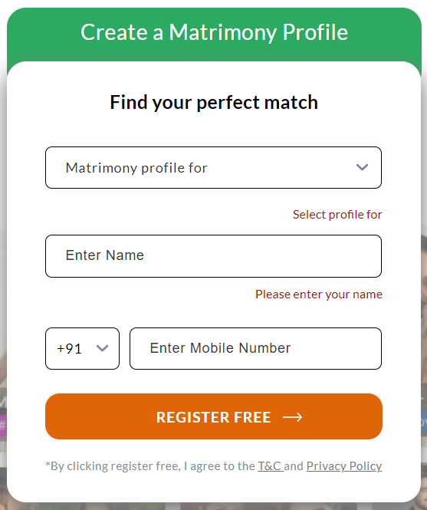

<https://www.bharatmatrimony.com/>

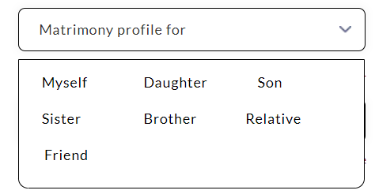

1. **Registration First Look Up**
2. **Registration Next Process**

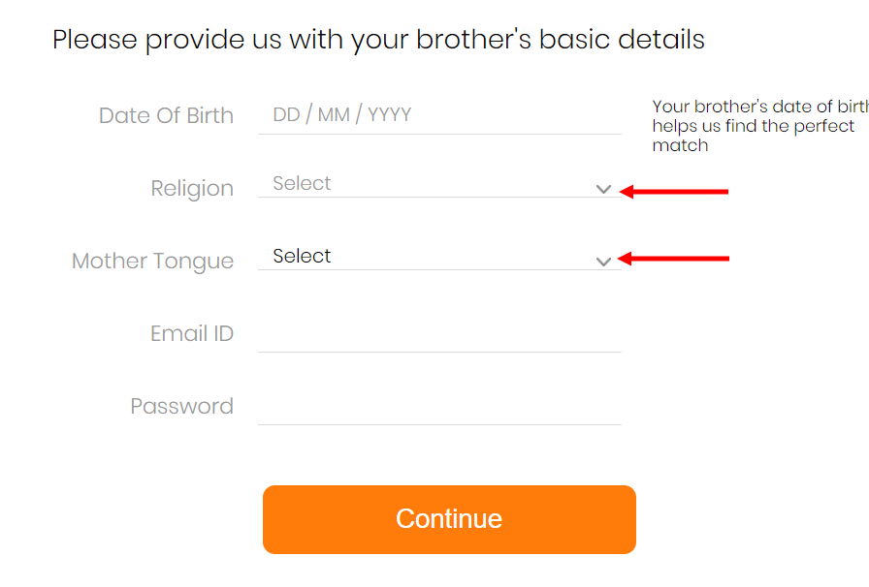

## **Religion/Caste details help us find better matches**

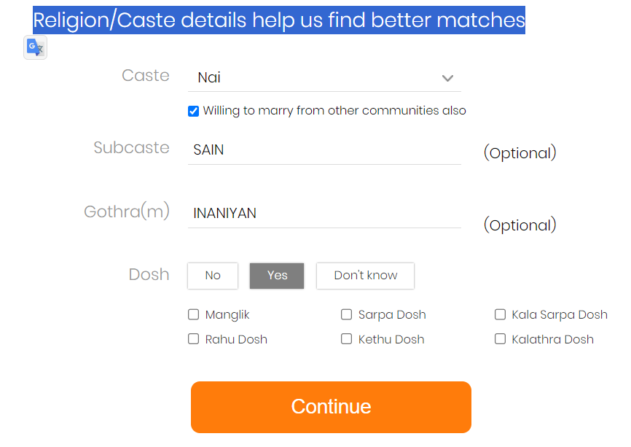

## 

## **Personal details get your brother the right matches**

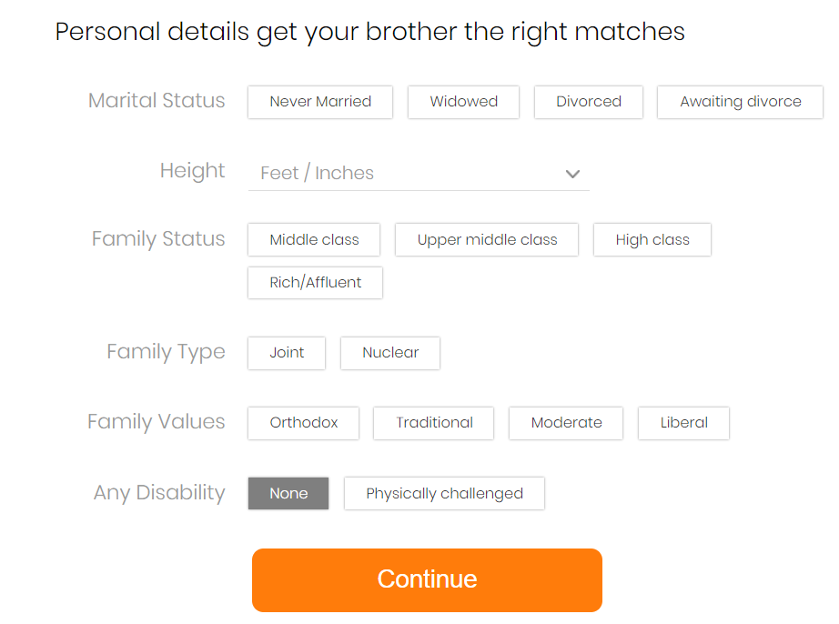

## Personal details get your brother the right matches

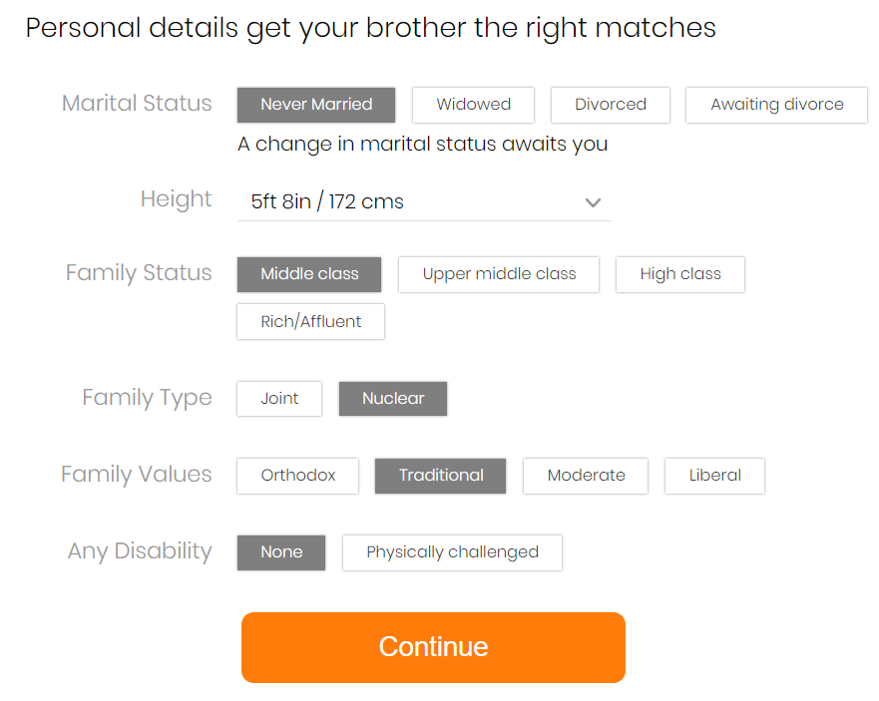

## **Professional details help your brother get relevant matches**

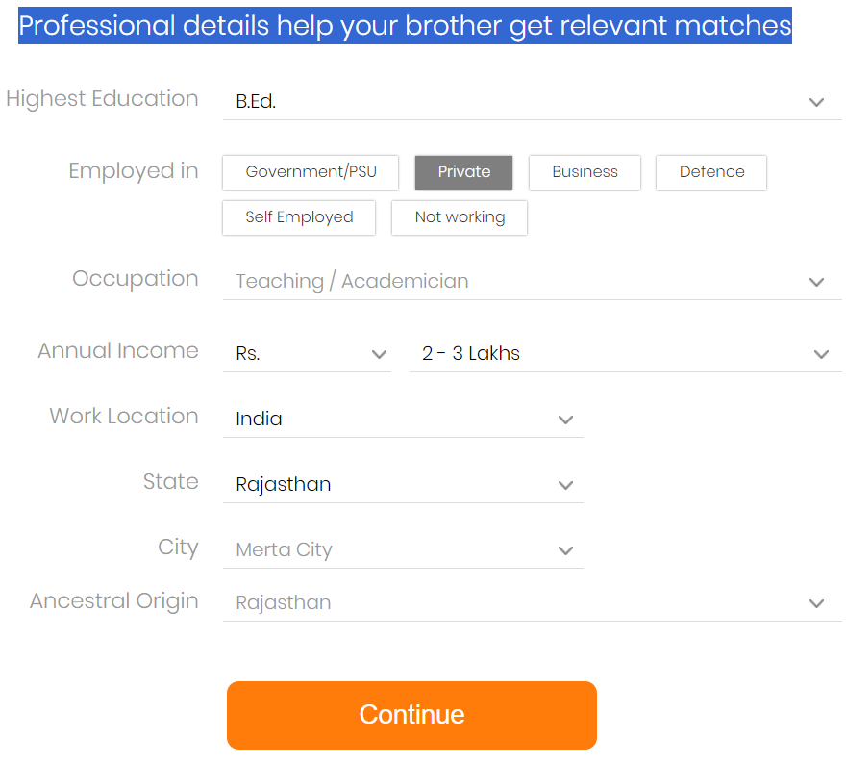

## Let's write something interesting about your brother

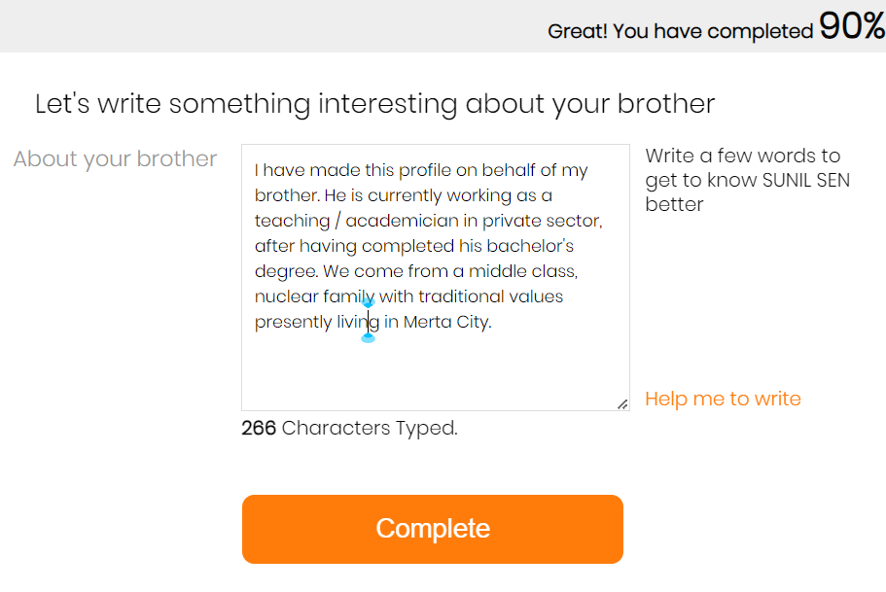

HELP ME TO WRITE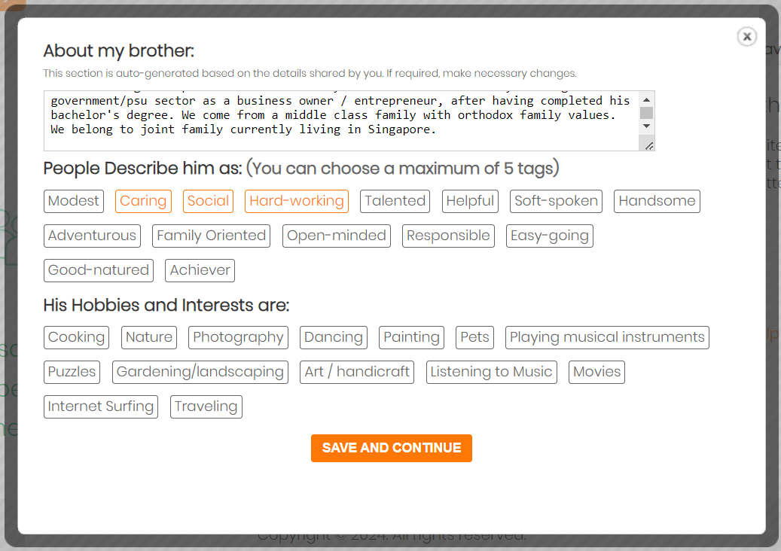

Verify Your Mobile Number

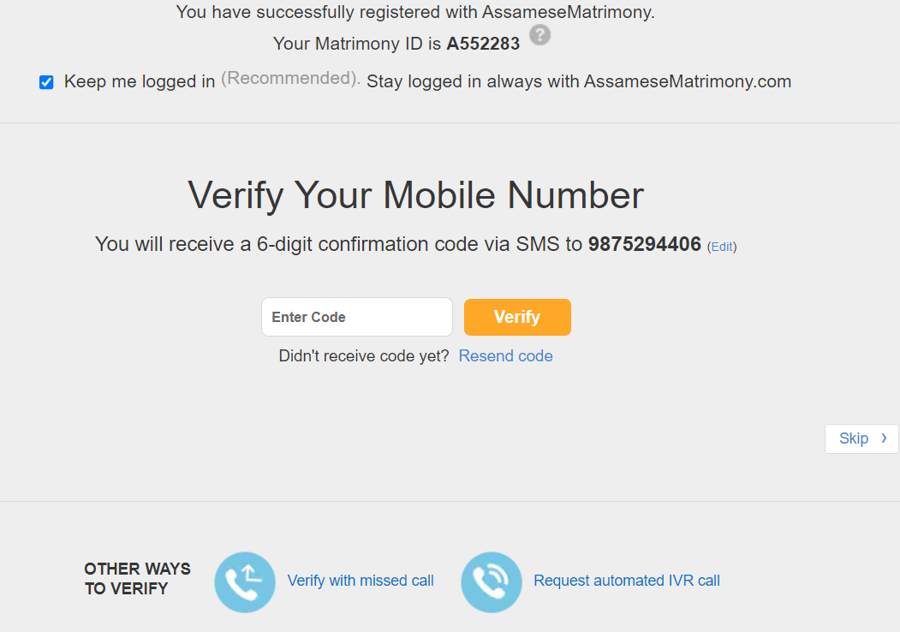

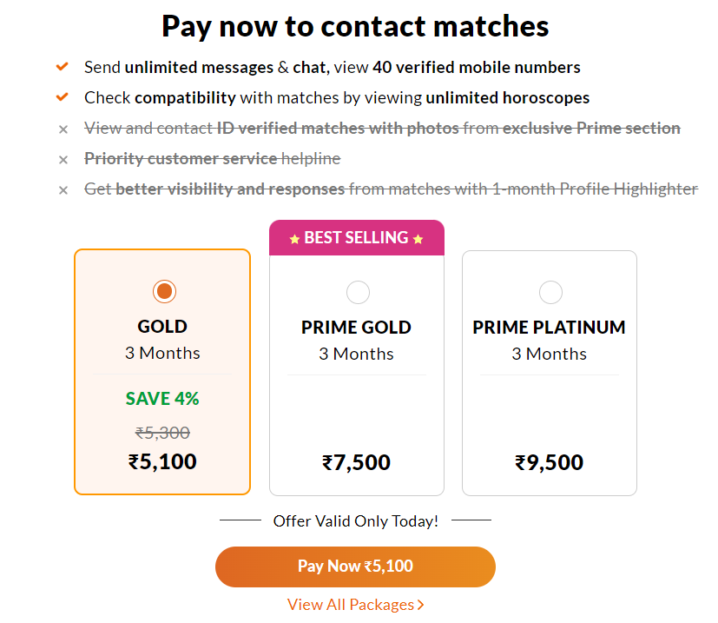

ALL PACKAGES

<https://bharatmatrimony.com/payments/paymentoptionnew.php?gaact=PAY&gasrc=MENUSUB&EncId=MjFiZTMzMDk1ZDMxNWUxYjM3NzA1MWIyODRkZWE0YWEwNTA4ZTJmM2Q=&Id=QTU1MjI4Mw==&referal=&gaact=PAY&gasrc=MENUSUB&OLDSCREEN=1>

View and send interest to the profiles you like. This will help us find similar profiles for you.

<https://profile.assamesematrimony.com/register/newregdailymatch.php?Pos=0>

PARTNER PERFERANCE

Partner Preferences

Basic Preferences

Groom's Age

21 - 28 Yrs

Height

4 Ft 6 In - 5 Ft 6 In

Marital Status

Never Married

Physical Status

Normal

Mother Tongue

Bihari, Hindi, Marwari, Rajasthani

Eating Habits

Doesn't Matter

Smoking Habits

Doesn't Matter

Drinking Habits

Doesn't Matter

Religious Preferences

Religion

Hindu

Caste

Prajapati, Caste no bar

Sub Caste

Any

Gothram

Star/Raasi

Any

Manglik

Doesn't Matter

Professional Preferences

Education

Any Bachelors in Engineering / Computers, Any Bachelors in Arts / Science / Commerce, Any Masters in Arts / Science / Commerce, Any Bachelors in Legal, Any Bachelors in Management, Any Bachelors in Medicine in General / Dental / Surgeon, Any Bachelors in Medicine Others, Diploma, Higher Secondary

Occupation

Any

Annual Income

Any

Location Preferences

Citizenship

Any

Country

Any

Residing State

Any

Residing City

Any

What I am looking for

Not Specified